Burndown Chart Version 1 and Sprint 2 Backlog  
  


5730511321 Warot Bhanuvesaya

5930278321 Nattamon Ayukarn

5931020921 Nattanai Na Songkhla

5931024421 Danoosit Techapetpaiboon

5931028021 Thanakrit Buranakarn

5931029621 Tanapon Suwankesawong

5931036021 Paphawit Boonyapongnukul

This project is a part of a course 2110423 Software Engineering   
Second Semester, Academic Year 2018  
Department of Computer Engineering,Faculty of Engineering, Chulalongkorn University

**Sprint 1 Backlog**

|  |  |  |  |  |  |  |  |  |  |  |  |  |  |  |  |  |  |
| --- | --- | --- | --- | --- | --- | --- | --- | --- | --- | --- | --- | --- | --- | --- | --- | --- | --- |
| Sprint ID | EPIC ID | EPIC Name | User Story ID | User Story | Task | Volunteer | Status | Original Estimate | Day 1 | Day 2 | Day 3 | Day 4 | Day 5 | Day 6 | Day 7 | Sprint Review |  |
|  |
| Sprint 1 | EPIC5 | Reserve | US5-1 | As an attendee, I want to reserve ticket for event so that I can attend this event certainly. | Create database server. | Warot,Tanapon, Paphawit | Done | 4 | 1 | 1 | 1 | 1 | 0 | 0 | 0 | 0 |  |
| Design UI. | Warot,Paphawit | Done | 4 | 1 | 1 | 1 | 1 | 0 | 0 | 0 | 0 |  |
| Code back-end. | Nattanai,Thanakrit, Tanapon | Done | 10 | 0 | 1 | 3 | 3 | 1 | 2 | 0 | 0 |  |
| Code the user interface. | Nattanai,Thanakrit | Done | 6 | 0 | 0 | 0 | 1 | 1 | 2 | 2 | 0 |  |
| Code the reserve function. | Tanapon,Danusit, Nattamon,Paphawit | Done | 12 | 0 | 0 | 2 | 2 | 1 | 3 | 4 | 0 |  |
|  |
| Test reserve function. | Danusit,Nattamon | Done | 4 | 0 | 0 | 0 | 0 | 0 | 2 | 2 | 0 |  |

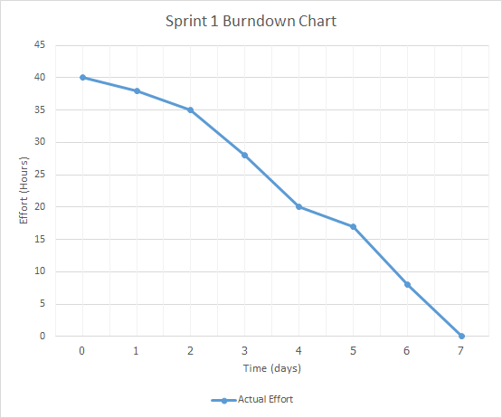

Sprint 2 Backlog

|  |  |  |  |  |  |  |  |  |  |  |  |  |  |  |  |  |
| --- | --- | --- | --- | --- | --- | --- | --- | --- | --- | --- | --- | --- | --- | --- | --- | --- |
| Sprint ID | EPIC ID | EPIC Name | User Story ID | User Story | Task | Volunteer | Status | Original Estimate | Day 1 | Day 2 | Day 3 | Day 4 | Day 5 | Day 6 | Day 7 | Sprint Review |
|
| Sprint 2 | EPIC4 | Discover Education Event | US4-1 | As an attendee, I want to see list of all education events so that I may interest in some events. | Create database server. | Warot,Tanapon, Paphawit | Todo | 4 |  |  |  |  |  |  |  |  |
| Design UI. | Danusit,Nattamon | Todo | 5 |  |  |  |  |  |  |  |  |
| Code back-end. | Nattanai,Thanakrit, Tanapon | Todo | 10 |  |  |  |  |  |  |  |  |
| Code the user interface. | Nattanai,Thanakrit | Todo | 7 |  |  |  |  |  |  |  |  |
| US4-2 | As an attendee, I want to search events by filter so that I can find appropriate events for me. | Design UI. | Danusit,Nattamon | Todo | 5 |  |  |  |  |  |  |  |  |
| Code back-end. | Nattanai,Thanakrit, Tanapon | Todo | 14 |  |  |  |  |  |  |  |  |
| Code the user interface. | Nattanai,Thanakrit | Todo | 7 |  |  |  |  |  |  |  |  |
| Code the search function. | Warot,Danusit, Nattamon, Paphawit | Todo | 16 |  |  |  |  |  |  |  |  |
| Test search function. | Warot,Paphawit | Todo | 4 |  |  |  |  |  |  |  |  |